EXTRACT from the International Standard ISO
This Extract does not replace the technical standard itself; it is only informative material about the standard.
Intelligent Transport Systems – CALM –  Infrared-Based Communication Systems | ISO 21214
Published in 2015, 144 pages
Extract prepared in 2026

Introduction
The ISO 21214 international standard (hereinafter referred to as the described document) introduces a set of functional requirements for the communication interface of an ITS station.
The concept of ITS communications (formerly CALM) is a set of requirements aimed at unifying communication systems within ITS. It introduces the concept of an ITS station, which represents the basic building block of this communication architecture. For more information, see the Extract from ISO 21217.
A key feature of the ITS station is its ability to use various communication protocols with different access technologies. The described document specifies the method of data exchange, via an infrared interface operating at wavelengths from 850 nm to 1010 nm, and expands the interface specification with compatibility with the ITS station according to ISO 21217. For the purposes of the standard, this interface is referred to as IR. This is the second edition of the standard.
Note: The Extract presents selected chapters of the described document, while sustaining the original chapter numbering.

Usage
The document establishes principles for implementing the IR interface into an ITS station within CALM.
For public administration authorities, it provides basic technical information to form an idea of the possibilities of using the IR interface in the ITS environment.For manufacturers of telematics devices and their operators, it defines the requirements for communication between ITS stations in the ITS interface environment.

1 Scope
The described document specifies requirements for the implementation of the IR communication interface into the access layer of the ITS-S station. The document further specifies requirements for the Communication Adaptation Layer (CAL) and the Management Adaptation Entity (MAE) layer of the ITS station.

2 Related Documents (Selection)
The chapter states the number of related (cited) documents in the described document and the most important of them, from Normative references or Bibliography. A clear designation of each document is sufficient; long lists are not reproduced.
EXAMPLE: The described document cites 12 normative references, mainly ISO 21217 (ITS station and communication architecture) and other CALM standards.

3 Terms and Definitions
The standard introduces 36 new terms. Other terms and abbreviations are provided in ISO 21217 and other CALM standards. In a separate paragraph, the standard introduces terms for the optical characteristics of the interface. Examples of terms and definitions:
communication zone – spatial zone in which two CALM-IR units are able to communicate with acceptable performance
registration phase – phase where a master identifies devices newly entering his communication zone
wake-up window; WuW – special case of a broadcast window and is used to “wake-up” sleeping units entering the communication zone of an active master

4 Abbreviations
The standard contains 82 abbreviations. Example abbreviations:
CIR circular QAM (a type of quadrature amplitude modulationcircular QAM)
HHH Hirt, Hassner, Heise (inventors of the HHH(1,13) code) (packet coding and modulation developed specifically for IR communication)
IR infrared (infrared-based communication interface)
McW multicast window
TDMA time division multiple access
θH horizontal opening angle
Other terms and abbreviations from the ITS domain can be found in the ITSTerminology dictionary (www.itsterminology.org), the StandardLand website (www.standardland.cz) or the OBP plataform (www.iso.org/obp).

5 Chapter title
This chapter, spanning 3 pages, defines the requirements for the IR receiver and IR transmitter in the form of parameter tables.
Article 6.1 Transmitter wavelengths and bandwidth and Article 6.2 – Radiated power, both on a single page, define the technical requirements for the transmitter (wavelength, bandwidth, radiated power). For example parameters, see Table 1. The chapter also defines 11 transmitter classes (based on radiated power).
5.1 Article title
Article 6.3 Receiver wavelengths and bandwidths and Article 6.4 – Receiver class span two pages and define, in the form of two tables, the technical requirements for the receiver (wavelength, bandwidth).

List format
This article defines:
- the basic set of requirements for modulation and coding in the IR environment
- the basic structure of a data packet at the OSI model physical layer
- interface communication profiles

Table format

Table 1 – IR transmitter parameter specification (Table 1 of the described document)
Parameter | Specification  Channel 870 Channel 970  (main channel) (alternative channel)
TX1 Nominal transmitter wavelength | 870 nm 970 nm
TX2 Transmitter pass band | 820 nm to 910 nm 920 nm to 1 010 nm
TX3 Coherence length | < 1 mm
TX4 Total radiated power | Dependent on transmitter class (see 6.2)
TX5 Minimum receiver in-band (RX2) radiated power | 80 % of TX4
TX6a Radiated power below pass band | not specified < 10 % of TX4
TX6b Radiated power above pass band | < 10 % of TX4 not specified

Figure format
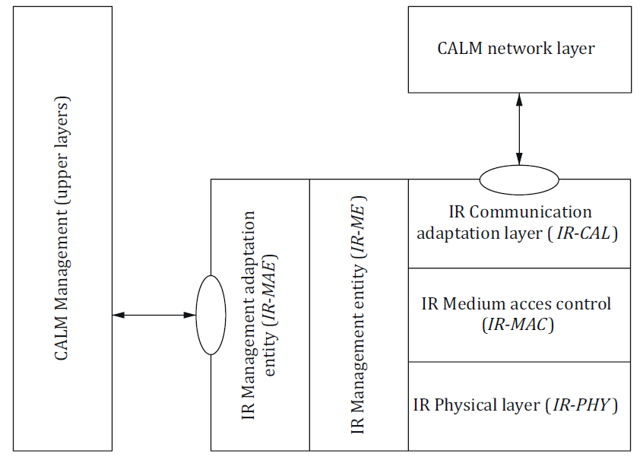
Figure 1 – Medium adaptation of the IR interface into the ITS station (Figure 17 of the described document)

Annex format

Annex A (normative) Coding and Error Correction of Profiles 0 and 1 and of Commands
This 2-page annex contains textual and tabular definitions of error correction algorithms for the given communication profiles.

Annex B (informative) Coding and Modulation of Profile 2 to Profile 6
This 7-page annex contains textual and tabular definitions of error correction algorithms for the given communication profiles.
(NOTE FOR AUTHORS – remove before submission)
• Title by type of the described document: EXTRACT from the European Standard / from the International Standard ISO / from the Technical Specification ISO (CEN) / from the Technical Report ISO (CEN).
• Designation, year and number of pages refer to the ISO or CEN edition the Extract describes; the national edition, classification code and ICS are not given. “Extract prepared in YYYY” states the year of the Extract (“…, updated YYYY” after a revision).
• Order: Introduction, Usage, 1 Scope, Related Documents, Terms and Definitions, Abbreviations, further chapters, annexes, bibliography; chapter numbers and titles follow the described document.
• Figures and tables are numbered separately from 1 in the order of the Extract; the caption gives the number in the described document in brackets. Table captions above the table, figure captions below the figure; code listings are treated as figures.

